J. (Junaid Jamshed) – Clothing & Lifestyle Store Management System using C++ (OOP Based)

Project Overview:
This project simulates a real-world clothing and lifestyle store, inspired by the popular Pakistani brand J. (Junaid Jamshed). It is built using Object-Oriented Programming (OOP) concepts in C++. The system is designed to manage product listings, customer shopping experiences, and admin inventory control through a simple console-based interface.
It includes two types of users: Admin and Customer. Admins manage the product database while customers can browse clothing categories, select sizes, add items to cart, and checkout. The system manages dynamic data using vectors and uses various OOP principles.

Objectives of the Project:
- To model a clothing and lifestyle store similar to Junaid Jamshed (J.).
- To implement OOP principles such as inheritance, abstraction, and polymorphism.
- To create an organized, user-friendly, menu-driven interface in C++.
- To manage clothing categories, sizes, and stock using vectors and object composition.

User Roles & Functionalities:

1. Admin Panel:
- Admin login.
- Add new clothing items with size, category, price, and stock.
- Update or delete products.
- View inventory and total stock.
- View customer orders or sales summary.

2. Customer Panel:
- Register and login.
- Browse categories (Men, Women, Kids, Perfumes, etc.).
- Filter by size (S, M, L, XL) and price.
- Add to cart and remove items.
- Checkout with bill generation.
- Logout or exit.

Core Features:
- Console-based text interface with menus.
- Clothing item management (name, category, size, price, stock).
- Customer cart system.
- Admin and customer login system.
- Invoice generation at checkout.
- Real-time stock updates after purchases.

OOP Concepts Used:
Concept | Implementation in Project
Classes & Objects | Product, User, Admin, Customer, Cart
Encapsulation | Private data for size, stock, price with public access methods
Inheritance | Admin and Customer derived from User class
Polymorphism | Overridden functions for display and menu handling
Abstraction | User base class with pure virtual functions
Aggregation | Cart aggregates Product objects
Association | Customer holds reference to their Cart
Friend Functions | Access specific data across classes
Vectors | To store dynamic lists of products and cart items

Technologies Used:
- Programming Language: C++
- Platform: Windows/Linux console
- Tools: Code::Blocks, Dev-C++, or Visual Studio

Sample Interface (Text-Based):
===== Welcome to J. Store =====
1. Register
2. Login
3. Exit
After login:
[Customer Menu]
1. Browse Categories
2. Search by Size or Price
3. Add to Cart
4. View Cart
5. Checkout
6. Logout
[Admin Menu]
1. Add Product
2. Update Product
3. Delete Product
4. View All Inventory
5. View Orders
6. Logout

Conclusion:
The J. (Junaid Jamshed) clothing store simulation project provides a practical application of C++ OOP in managing a fashion retail system. It demonstrates the use of core programming principles in solving real-world problems while giving students experience in building dynamic and modular systems with clean architecture.

Class Diagram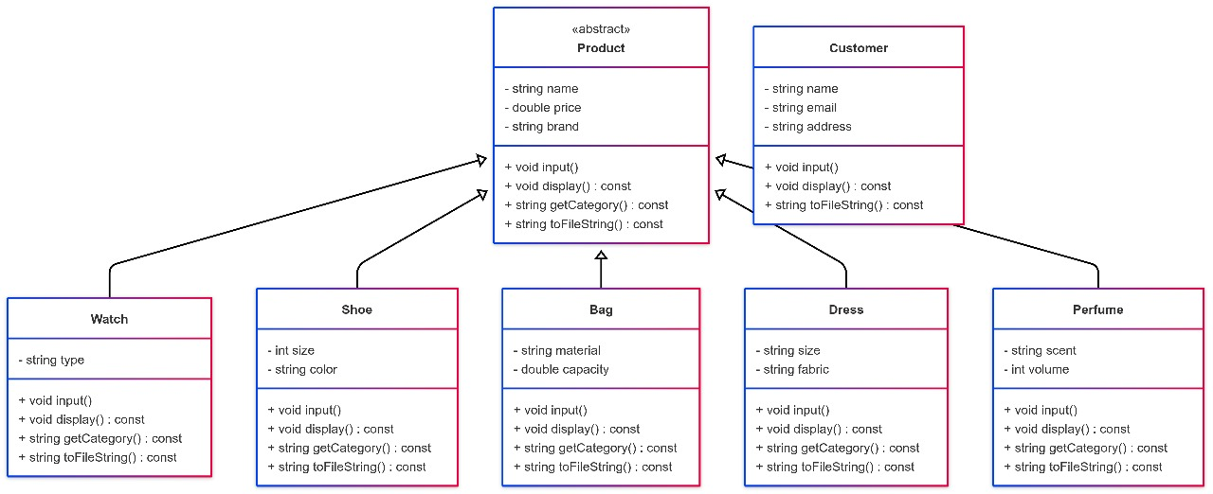
Code:
#include <iostream>
#include <vector>
#include <string>
#include <fstream>
#include <sstream>
#include <stdexcept>

using namespace std;

class Product {
protected:
string name;
double price;
string brand;

public:
Product(string n = "", double p = 0.0, string b = "") : name(n), price(p), brand(b) {}

virtual void input() {
cin.ignore();
cout << "Enter product name: ";
getline(cin, name);
cout << "Enter brand: ";
getline(cin, brand);
cout << "Enter price: ";
cin >> price;
cin.ignore();
}

virtual void display() const {
cout << "Name: " << name << "\nBrand: " << brand << "\nPrice: $" << price << endl;
}

virtual string getCategory() const = 0;
virtual string toFileString() const = 0;

virtual ~Product() {}
};

class Watch : public Product {
public:
string type;

Watch(string n = "", double p = 0.0, string b = "", string t = "") : Product(n, p, b), type(t) {}

void input() override {
Product::input();
cout << "Enter type (Analog/Digital): ";
getline(cin, type);
}

void display() const override {
Product::display();
cout << "Type: " << type << "\nCategory: Watch\n" << endl;
}

string getCategory() const override { return "Watch"; }

string toFileString() const override {
return "Watch," + name + "," + brand + "," + to_string(price) + "," + type;
}
};

class Shoe : public Product {
public:
int size;
string color;

Shoe(string n = "", double p = 0.0, string b = "", int s = 0, string c = "") : Product(n, p, b), size(s), color(c) {}

void input() override {
Product::input();
cout << "Enter size: ";
cin >> size;
cin.ignore();
cout << "Enter color: ";
getline(cin, color);
}

void display() const override {
Product::display();
cout << "Size: " << size << "\nColor: " << color << "\nCategory: Shoe\n" << endl;
}

string getCategory() const override { return "Shoe"; }

string toFileString() const override {
return "Shoe," + name + "," + brand + "," + to_string(price) + "," + to_string(size) + "," + color;
}
};

class Bag : public Product {
public:
string material;
double capacity;

Bag(string n = "", double p = 0.0, string b = "", string m = "", double c = 0.0)
: Product(n, p, b), material(m), capacity(c) {}

void input() override {
Product::input();
cout << "Enter material (Leather/Canvas/etc.): ";
getline(cin, material);
cout << "Enter capacity (in liters): ";
cin >> capacity;
cin.ignore();
}

void display() const override {
Product::display();
cout << "Material: " << material << "\nCapacity: " << capacity << " liters\nCategory: Bag\n" << endl;
}

string getCategory() const override { return "Bag"; }

string toFileString() const override {
return "Bag," + name + "," + brand + "," + to_string(price) + "," + material + "," + to_string(capacity);
}
};

class Dress : public Product {
public:
string size;
string fabric;

Dress(string n = "", double p = 0.0, string b = "", string s = "", string f = "") : Product(n, p, b), size(s), fabric(f) {}

void input() override {
Product::input();
cout << "Enter size (S/M/L/XL): ";
getline(cin, size);
cout << "Enter fabric (Cotton/Silk/etc.): ";
getline(cin, fabric);
}

void display() const override {
Product::display();
cout << "Size: " << size << "\nFabric: " << fabric << "\nCategory: Dress\n" << endl;
}

string getCategory() const override { return "Dress"; }

string toFileString() const override {
return "Dress," + name + "," + brand + "," + to_string(price) + "," + size + "," + fabric;
}
};

class Perfume : public Product {
public:
string scent;
int volume;

Perfume(string n = "", double p = 0.0, string b = "", string s = "", int v = 0) : Product(n, p, b), scent(s), volume(v) {}

void input() override {
Product::input();
cout << "Enter scent (Floral/Woody/etc.): ";
getline(cin, scent);
cout << "Enter volume (ml): ";
cin >> volume;
cin.ignore();
}

void display() const override {
Product::display();
cout << "Scent: " << scent << "\nVolume: " << volume << " ml\nCategory: Perfume\n" << endl;
}

string getCategory() const override { return "Perfume"; }

string toFileString() const override {
return "Perfume," + name + "," + brand + "," + to_string(price) + "," + scent + "," + to_string(volume);
}
};

class Customer {
public:
string name;
string email;
string address;

void input() {
cin.ignore();
cout << "Enter customer name: ";
getline(cin, name);
cout << "Enter customer email: ";
getline(cin, email);
cout << "Enter customer address: ";
getline(cin, address);
}

void display() const {
cout << "\nCustomer Name: " << name << "\nEmail: " << email << "\nAddress: " << address << endl;
}

string toFileString() const {
return name + "," + email + "," + address;
}
};

void saveProductsToFile(const vector<Product*>& products, const string& filename) {
ofstream outFile(filename);
if (!outFile) {
throw runtime_error("Unable to open file for writing.");
}

for (const auto& product : products) {
outFile << product->toFileString() << endl;
}
outFile.close();
}

void loadProductsFromFile(vector<Product*>& products, const string& filename) {
ifstream inFile(filename);
if (!inFile) {
throw runtime_error("Unable to open file for reading.");
}

products.clear();
string line;
while (getline(inFile, line)) {
stringstream ss(line);
string category;
getline(ss, category, ',');

if (category == "Watch") {
string name, brand, type, priceStr;
getline(ss, name, ',');
getline(ss, brand, ',');
getline(ss, priceStr, ',');
getline(ss, type);
double price = stod(priceStr);
products.push_back(new Watch(name, price, brand, type));
} else if (category == "Shoe") {
string name, brand, priceStr, sizeStr, color;
getline(ss, name, ',');
getline(ss, brand, ',');
getline(ss, priceStr, ',');
getline(ss, sizeStr, ',');
getline(ss, color);
double price = stod(priceStr);
int size = stoi(sizeStr);
products.push_back(new Shoe(name, price, brand, size, color));
} else if (category == "Bag") {
string name, brand, priceStr, material, capacityStr;
getline(ss, name, ',');
getline(ss, brand, ',');
getline(ss, priceStr, ',');
getline(ss, material, ',');
getline(ss, capacityStr);
double price = stod(priceStr);
double capacity = stod(capacityStr);
products.push_back(new Bag(name, price, brand, material, capacity));
} else if (category == "Dress") {
string name, brand, priceStr, size, fabric;
getline(ss, name, ',');
getline(ss, brand, ',');
getline(ss, priceStr, ',');
getline(ss, size, ',');
getline(ss, fabric);
double price = stod(priceStr);
products.push_back(new Dress(name, price, brand, size, fabric));
} else if (category == "Perfume") {
string name, brand, priceStr, scent, volumeStr;
getline(ss, name, ',');
getline(ss, brand, ',');
getline(ss, priceStr, ',');
getline(ss, scent, ',');
getline(ss, volumeStr);
double price = stod(priceStr);
int volume = stoi(volumeStr);
products.push_back(new Perfume(name, price, brand, scent, volume));
}
}
inFile.close();
}

int main() {
vector<Product*> products;
vector<Customer> customers;
int choice;

do {
cout << "\n=== Product Management System ===\n";
cout << "1. Add Watch\n";
cout << "2. Add Shoe\n";
cout << "3. Add Bag\n";
cout << "4. Add Dress\n";
cout << "5. Add Perfume\n";
cout << "6. Add Customer\n";
cout << "7. Display All Products\n";
cout << "8. Display All Customers\n";
cout << "9. Save to File\n";
cout << "10. Load from File\n";
cout << "11. Exit\n";
cout << "Enter your choice: ";
cin >> choice;

switch (choice) {
case 1:
products.push_back(new Watch());
products.back()->input();
break;
case 2:
products.push_back(new Shoe());
products.back()->input();
break;
case 3:
products.push_back(new Bag());
products.back()->input();
break;
case 4:
products.push_back(new Dress());
products.back()->input();
break;
case 5:
products.push_back(new Perfume());
products.back()->input();
break;
case 6: {
Customer c;
c.input();
customers.push_back(c);
break;
}
case 7:
for (const auto& p : products) p->display();
break;
case 8:
for (const auto& c : customers) c.display();
break;
case 9:
try {
saveProductsToFile(products, "products.txt");
cout << "Products saved to file successfully.\n";
} catch (const exception& e) {
cerr << e.what() << endl;
}
break;
case 10:
try {
loadProductsFromFile(products, "products.txt");
cout << "Products loaded from file successfully.\n";
} catch (const exception& e) {
cerr << e.what() << endl;
}
break;
case 11:
cout << "Exiting program.\n";
break;
default:
cout << "Invalid choice. Try again.\n";
}
} while (choice != 11);

for (auto p : products) delete p;

return 0;
}

